SOUTHWEST FLORIDA BLUES SOCIETY
2024 REGIONAL IBC
International Blues Challange
Hosted by: Mango Rita’s Rhythm House
Phone (239) 466-8326

The Southwest Florida Blues Society’s, “Road to Memphis”. (Press Release)

Local and Regional Blues Artists are Invited! Our Winning Artists get a shot at the Memphis Blues scene and the largest single gathering of blues artists in the world. The Southwest Florida Blues Society and Mango Rita’s Rhythm House will be partnering on Sunday, August 25th, 2024, to present this year’s Annual Southwest Florida Regional I.B.C. For the winners, this sets in motion a historic trip, setting them squarely on the “Road to Memphis” and the International Blues Challenge, held on the legendary Beale Street entertainment district.

This competition is for Bands and Solo/Duo musicians who are interested in a higher level of Regional, National and International recognition. There is also a Youth Showcase category, that provides our younger artists (all members are 21 or under during the Memphis IBC) with an opportunity to perform in Memphis during the Youth Showcase event. In large part this category is a who’s who of upcoming blues talent that you’ll want to keep an eye on. The Regional IBC creates an environment where the winners are in a better position to negotiate new gigs, by validating their talent through a group of independent judges during the regional competition. Winning the regional IBC helps increase their recognition and marketability. This opportunity could even lead to signing with a major record label or gaining the recognition needed to work with some of the industry’s leading agents, promoters and event organizers.

Winning the (SWFBS) Regional I.B.C. and then later competing at the "I.B.C." in Memphis could provide our artists with some if not all the options we just described above. There are hundreds of bands that compete worldwide every year for this opportunity, and you can only get there when you've been selected by a Blues Foundation Affiliate Member to compete. "Your local S.W.F.B.S. is a Blues Foundation affiliate member." In the past, Memphis competitors have included as many as 255 acts from 40 states, and 16 countries (and four continents). One of which, was our 2019 Southwest Florida Blues Society Regional winner, Josh Rowand and “The Pitbull of Blues Band”. Josh and the Band finished 3rd. overall in Memphis in 2020, playing at the iconic Orpheum Theater.

Right now, is an exciting time to be a blues band and a blues fan here in southwest Florida. New bands and venues are becoming more prevalent every day. Opportunities like the IBC only come around once a year and only in specific locations. This will undoubtedly be a day to remember with some of our best entertainers in one location competing for a chance to go to the I.B.C. in Memphis and represent the Southwest Florida Blues Society and our/your fans.

Cash prizes are always awarded to our regional winners, in order to help offset their travel expenses to Memphis. The modest door cover charge during the regional competition helps do that. Fans are encouraged to come and vote for a “people’s choice award winner” which only garners that act a trophy and local bragging rights for the following year. People’s choice winner, on its own does not advance to Memphis.
We invite you to come out for a great day of music, as well as the opportunity to vote for your favorite act.
Besides great music, Mango Rita’s will be providing some tasty food and ice-cold beverages, there will also be Society T’s, 50/50 raffle, usually ticket giveaways and our popular spin-to-win game, which are some of the things you can look forward to on Sunday, August 25th. 2024 at Mango Rita’s Rhythm House.

Interested Blues Musicians can register now for this amazing competition. You can be assured this event will include a fantastic day of talented musicians. Our previous competitions have included memorable performances by Josh Rowand and the Pitbull of Blues Band, The Marty Stokes Band. The RJ Howson band, The Mark Telesca Band, Little Eddie and the Fat Fingers and CC Bronson just to name a few. This can quickly become a standing room only event, so we encourage you and blues fans to come early, as seating is on a first come basis. Mark your calendars and get out to Mango Rita’s Rhythm House early for a day of top-notch blues entertainment, cold beverages, and some mouthwatering food.

Some additional competition details can be found on page three of this notice. This is also being presented as a PSA announcement below. Complete details and registration forms are on our website at; https://SWFBS.org just follow the “International Blues Challenge” navigation links at the top of the page.

Thank You for Your Participation and Support,
Southwest Florida Blues Society
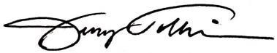
Jerry Tolliver, Vice President
and our “Board of Directors”
email: directors@swfbs.org

Jerry Tolliver, Vice President Southwest Florida Blues Society A 501c3 Non-Profit Corporation
c. 239-464-0809 - email: jerry@swfbs.org

Regional “I.B.C.” Competition
A Southwest Florida Blues Society Nonprofit Event
Event Date: Sunday, August 25th 2024 | 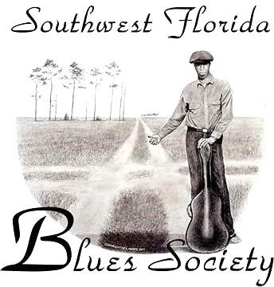  Website & I.B.C. Details:  www.SWFBS.org  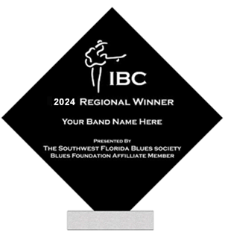  Regional Winners will receive SWFBS Awards
Doors Open: 12:00 Noon
Competition Time: 1:00 PM until 6:00pm (ish)
Location: Mango Rita’s Rhythm House
16440 S Tamiami Trail #11, Fort Myers, FL 33908
(239) 466-8326

Contact: Jerry Tolliver email: jerry@swfbs.org c. 239-464-0809
Alternate: Kent Newman, Pres.
email: kentn@swfbs.org
c.239-292-5291
Admission for this day-long event is only:
SWFBS Members $10.
Non-Members $20.
You can become a member at the event.
Description:
“International Blues Challenge”
A Regional Southwest Florida Competition.

The 1st. Place Winner(s), in each category will advance to the, January 7-11, 2025 Worldwide, I.B.C. in Memphis TN.

The Southwest Florida Blues Society and Mango Rita’s Rhythm House invite you to come out to support your favorite band and enjoy this year’s competition. There will also be a “People’s Choice award, “Come out and Vote!” Mango Rita’s will also be creating a special menu for this event, along with their complete line of cold beverages.

“It’s the blues”, there is always the possibility of a special guest performance at the end of the day? You don’t want to miss this year’s Regional I.B.C. at,
Mango Rita’s Rhythm House,
16440 S Tamiami Trail #11,
Fort Myers, FL 33908

